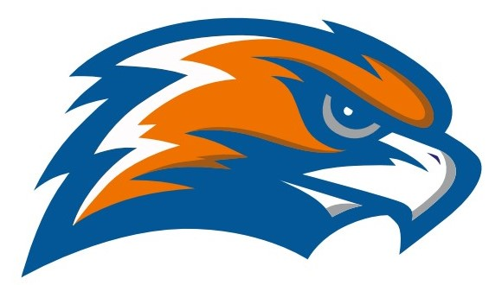

| **GARRETT MORGAN**  **SOFTBALL 2022**  **Senate Athletics League** |
| --- |

**Head Coach Gabe Bewley Principal GMSEI Quenton Davis Assistant Coach Cherie Morgan Principal GMSLI Anshawn Ivery**

**Athletic Director Jennifer Smith**

| **DATE** | **TIME** | **release** | **VISITOR** | **HOME** | **SITE** |
| --- | --- | --- | --- | --- | --- |
| Tuesday  4/5 | 5:00 | 3:20 | Lincoln West | Garrett Morgan | Fairview Park |
| Thursday  4/7 | 5:00 | 3:20 | Max Hayes | Garrett Morgan | Fairview Park |
| Friday  4/8 | 5:00 | 2:45 | Garrett Morgan | Open Door Christian Academy | ODCA HS |
| Monday  4/11 | 5:00 | 3:20 | Bard (JV) | Garrett Morgan | Fairview Park |
| Tuesday  4/12 | 5:00 | 3:20 | John F. Kennedy | Garrett Morgan | Fairview Park |
| Thursday  4/14 | 5:00 | 3:20 | Garrett Morgan | Glenville | Gordon 4 |
| Tuesday  4/19 | 5:00 | 3:15 | Garrett Morgan | James F. Rhodes | Estabrook |
| Thursday  4/21 | 5:00 | 3:20 | Bard | Garrett Morgan | Fairview Park |
| Friday  4/22 | 5:00 | 2:40 | Garrett Morgan | Oberlin | Oberlin H.S. |
| Tuesday  4/26 | 5:00 | 3:20 | Garrett Morgan | Campus International | Gordon 2 |
| Thursday  4/28 | 5:00 | 3:20 | Garrett Morgan | John Hay | Gordon 5 |
| Friday  4/29 |  |  | Garrett Morgan | Bard JV | Estabrook |
| Tuesday  5/3 | 4:00 | 3:15 | Garrett Morgan | John Marshall | Brookside Rose |
| 5/7 - 5/14 |  |  | OHSAA Sectionals |  |  |

**PLAYOFFS Thursday, May 12, 2022**

4TH  PLACE VS. 1ST PLACE 4:00 PM TBA

3RD  PLACE VS. 2ND PLACE 4:00 PM TBA

###### **CHAMPIONSHIP GAME Monday May 23 TBA**

##### **Tuesday 5/24 (rain make-up)**

**Senate Athletic League**

**Bard**

**Campus International**

**Garrett Morgan**

**Glenville**

**James F. Rhodes**

**John Hay**

**John Marshall**

**Lincoln-West**

**Max Hayes**

**John F. Kennedy**